**BSC235TE05A MANAGEMENT INFORMATION SYSTEM (L T P C: 3 1 0 4)**

**(For Students admitted from 2023 onwards)**

**Common for B.Sc. (CS) / BCA / B.Sc. (Data Science) / B.Sc. (Cyber Security)**

**COURSE OBJECTIVES**

•To describe the role of information technology and decision support systems in

business.

•To introduce the fundamental principles of computer-based information systems

analysis.

•To enable the students to understand the various knowledge representation methods.

•To enable the students to use information to assess the impact of the Internet and

Internet technology on electronic commerce

•To provide the theoretical models used in database management systems to answer

business questions.

**COURSE OUTCOMES**

•Relate the basic concepts and technologies used in the field of management

information systems;

•Compare the processes of developing and implementing information systems.

•Outline the role of the ethical, social, and security issues of information systems.

•Translate the role of information systems in organizations, the strategic management

processes, with the implications for the management.

•Apply the understanding of how various information systems like DBMS work

together to accomplish the information objectives of an organization.

**SYLLABUS: UNIT – I:** Introduction: Definition of key terms – Management Information, System – Nature and Scope of MIS - Kinds of System; Systems Approach – Classification of MIS **12**

**UNIT – II:** Organization for MIS: Structure for Management; Information requirements at various levels of Management; Manual vs. computerized information system; Data Bank Concept; Types of Computer-Based /applications **12**

**UNIT – III:** Data Base Management: Meaning of Data-Base; Electronic Data-Base; DBMS – Objectives –Technical Overview – Data Aggregates – Physical and Logical Structures; System Security **12**

**UNIT – IV:** System Development Stages: Investigation, Analysis Design, Construction, Testing,

Implementation, Maintenance **12**

**UNIT – V:** MIS in functional areas of Management: MIS for Marketing, Human Resource, Operations, Finance, General Management – Decision Making. **12 TOTAL: 60**

**TEXT BOOKS**

1. Goyal, Management Information Systems, Managerial Perspectives, Macmillan India

Limited, New Delhi, 2014.

2. Jawadekar, W.S., “Management Information Systems”, Tata McGraw Hill Private

Limited, New Delhi, 2009.

3. Kenneth C. Laudon and Jane P. Laudon: “Management Information Systems” 9/e,

Pearson Education, New Delhi.

**REFERENCE BOOKS**

1. Mahadeo Jaiswal, Monika Mital: “Management Information System”, Oxford

University Press, New Delhi, 2008.

2. Murthy C.S.V.: “Management Information System”, Himalaya Publ, New Delhi, 2008.

3. Panneerselvam R.: “Database Management System”, PHI Private Limited, New

Delhi, 2008.

**Notes**

**UNIT – I:** Definitions– Nature and Scope of MIS - Kinds of System; Systems Approach – Classification of MIS

Introduction: Whether it is industry, commerce, defense, transport, tourism, banking, education, economics or politics,… updated information is needed everywhere.

exponential growth of information regarding the choice of technology, skill, money and material, competitive products, sales techniques makes it necessary that information is collected, stored and retrieved when needed.

**Definition of key terms:**

**Management:**

**-** has been viewed as be function, a process, a profession and a class of people.

- It refers to the kind of task and activities that are perform by managers.

- The specific nature of the activities is determined by such managerial functions as planning, organising, directing, leadership and controlling.

1. **Planning:** Its objectives in the best possible manner and for anticipating future opportunities and problems. It is the process of deciding in advance the courses of action to be followed and when and how to undertake these.

2. **Organising:** It is formal grouping of people and activities to facilitate achievement of the farm’s objectives. It is need for assigning responsibilities, jobs and hierarchy among personnel. Organizing is job oriented, staffing is worker-oriented

3. **Controlling:** It is the checking the progress of plans and correcting any deviations that may occur along the way. (setting benchmark expectations, scaling, comparing with actual performance, corrections and improvements)

4. **Directing:** It is the process of activating the plans, structure and group efforts desired direction. It is needed for implementation of plans by providing desired leadership motivation and proper communication. (comm, motivation, leadership)

**Management Hierarchy:**

* Top management
* Middle or Tactical management
* Junior or Operational management

1. **Top Management:** Establishes the policies, plans, objectives and budget framework under which various departments will operate of the organisation.
2. **Middle Management:** has the responsibility of implementing the policies and overall plans of the top management.
3. **Junior Management**: has the responsibility of implementing day to day operations and decisions of the middle management to produce goods and services to meet the revenue, profit and other goals.
4. 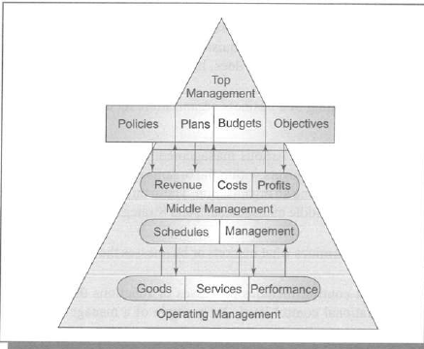

**Operation needs at different levels of management:**

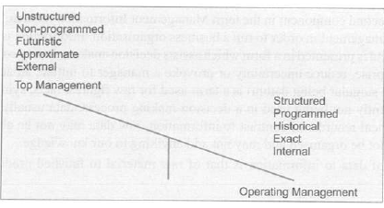

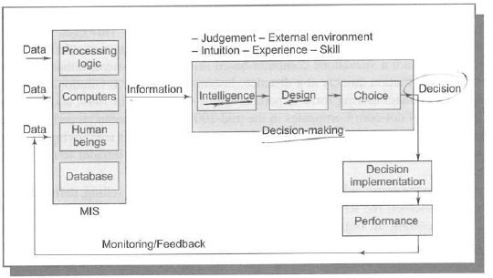

**Inter disciplinary nature of MIS:**

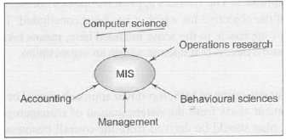

**Information:**

* the data which is organised and presented at a time and place so that the decision-maker may take necessary act as a basis for forecasting
* Data🡪Process🡪Info🡪decision🡪action

**System:**

* System-SubSystem hierarchy is a group of natural or man-made inter-connected elements or components joined together to fulfil certain functions
* Ex: Factory System
  + production subsystem,
    - production control,
    - material control,
      * purchasing,
      * stores,
      * transportation,
      * inspection
    - quality control
  + marketing sub-system,
  + personnel sub-system and
  + financial sub-system.

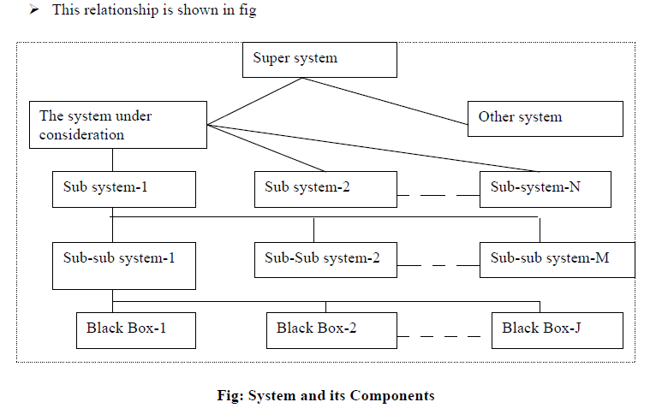

**Definition of MIS:** 1. According to Schwartz, ‘MIS is a system of people, equipment, procedure, documents and communication that collects, validates, operates on transformers, stores, retrieves and present data for use in planning, budgeting, accounting, controlling and other management process’.

2. According to Jerome Kanter, ‘MIS is a system that aids management in making, carrying out and controlling decisions’.

3. According to Davis and Olson, ’MIS is an integrated user machine system designed for providing information to support operational control, management control and decision making functions in an organisation. The information systems make use of resources such as hardware, software, man, procedures as well as suppliers’.

**FRAMEWORK FOR MIS ORGANISATION AND MANAGEMENT TRIANGLE**

Robert Anthony in 1965 suggested that the area of management planning and control can be divided into 3 categories. These are:

 **Strategic planning:** develops the strategy for deciding objectives of the organisation and introducing changes in those objectives, formulating policies to govern procurement, use and disposition of those resources.

 **Management control:** is needed by managers of a various departments to measure the performance, decide on control action, formulate new decision rules and allocate resources.

 **Operational control:** It is the processes of operational activities are carried out to achieve optimum use of resources. It makes use of pre-established procedures and decision rules.

Top, Middle and Junior (TMJ) levels of management responsible for each of these respectively.

The availability of information to management at various levels has improved due to three reasons. **Development of telecommunications, Processing of data with computer, Video technology**

**Information Classification**

1. Action vs. non-action information

2. Recurring vs. non recurring information

3. Documentary vs. non documentary information

4. Internal vs. external information

5. Historical information vs. future projections:

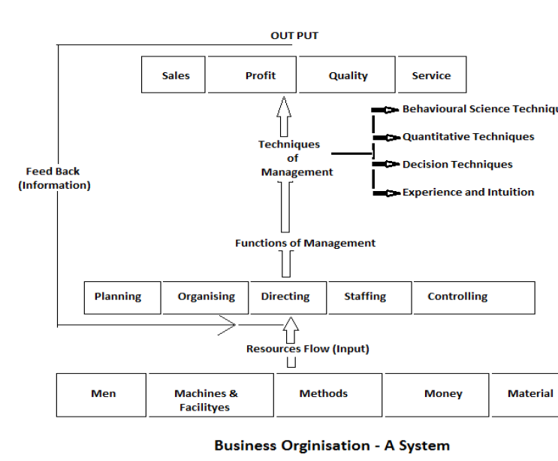

**Classification of systems:**

➢ **The conceptual system** is concerned with theoretical structures which may or may not have any counterpart in the real world. Examples of such systems are economic theory, organization theory, general system of relativity etc.

➢ **Empirical systems** are concrete operational systems made up of people, materials, machines, energy, and other physical things. Other systems such as electrical, thermal and chemical are also fall into this category.

**1. Natural and man-made systems**: The examples of natural systems are: human body, solar system, etc. Examples of man-made systems are: Transportation system, communication system, education system, business organisation etc.

**2. Social system:** A system made up of people may be taken as a social system, such as business organisations, government agencies, political parties, social clubs, professional societies etc.

**3. Man-machine system**: Most empirical systems fall into the category of man-machine systems. One of the examples of this system is aeroplane.

**4. Open and closed systems:**

➢ An open system continually interacts with its environment. This type of system can adapt to changing internal and environmental conditions. Every social and business organization is open because it reacts with its unpredictable environment

➢ A closed system is one of that does not interact with its environment. This system does not change or if it does then a barrier exists between the system and the environment to prevent the system from being affected.

**System life cycle:** A MIS business has the following four phases in its life cycle:

**1. Study phase:** concerned with

1. Identification of the problems

2. Study of the present system and its effectiveness

3. Identification and evaluation of various alternative courses of action

4. Selection of the most appropriate course of action as per the objective.

**2. Design phase:**

1. Identification of the function to be performed

2. Study of the input/output and life cycle design

3. Defining basic parameters of system design.

**3. Development phase:** the decision about the selection and use of hardware and software is taken.

**4. Implementation phase:** The system designed is given practical shape and is adopted for use.

**MEANING AND OBJECTIVES OF MIS**

**➢ Meaning:** MIS is an integrated man-machine system which collects, maintains, correlates and selectively displays information in the proper time frame consistently, to meet the specific needs of various levels of management in order that decisions could be made and action taken for fulfilling the objectives of an organisation.

In other words it is a system which:

i. Provides information to support managerial function. (Planning, control, organising, operating)

ii. Collects information systematically and routinely in accordance with a well-defined set of rules.

iii. Includes files, hardware, software and operations research models of processing, storing, retrieving and transmitting information to the users.

**➢ Objectives:** Facilitate, Provide, Help, Support

**Categories of MIS:** MIS can be subdivided into following four categories:

1. **Transaction processing system (TSP)**: deals with collecting and processing a large volume of data which mainly helps junior level management in discharging their responsibilities.

**2. Information providing system (IPS):** meant for processing information, making a summary of information, and providing exceptional reports.

**3. Decision support system (DSS):** helps in improving the analytical capability of the decision maker by creating interactive model of the real life situation.

4. **Programmed decision-making system**: Programs are simply a string of instruction as to accomplish a job or a task, rather than a person.

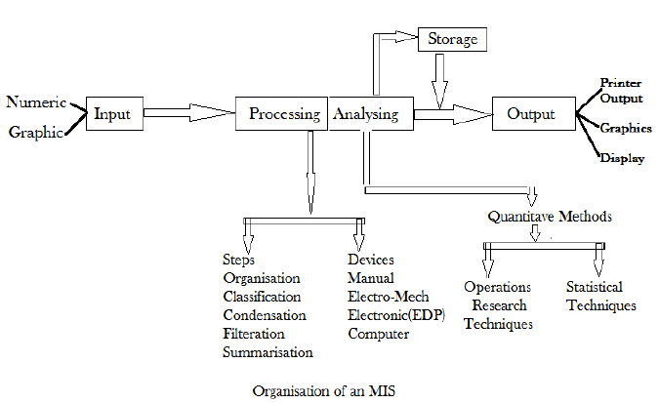

**4 Classification of MIS:**

1. **Data bank information system:** week, just stores/retrieves data for user, not used for any decision making



1. **Predictive information system:** extends data bank system to help specific data report



1. **Decision making information system:** helps with info across system to take decision
2. **Decision taking information system:** to be cautious as this is fully automated like auto replenishment, etc

**Implementation of MIS** involves the following steps:

1. Preparing organisational plans.

2. Planning of work flow.

3. Training of personnel.

4. Development of software.

5. Acquiring computer hardware.

6. Designing the format for data collection.

7. Construction of data files.

8. Operation of old and new systems in parallel.

9. Phasing out the old and inducting the new system.

10. Evaluation, maintenance and control of the new system.

**Disadvantages of MIS:** Deskilling of workers(layoffs), Info overload/excess, employee mistrust, competitive pressure, Disenchantment with IS (Non achieved org goals as promised with IS), security breaches

**MIS development approaches:**

1. **Top down:** Management decides, plans, designs, circulate
2. **Bottom up:** Consists 5 steps
   1. Individual depts. Moves/migrate to way of file handling, reports, communication
   2. Various individual departments applications are integrated with data/indexing into DB
   3. Applications developed on DB for various departments, mgmt. and role specific
   4. Wide verity of analysis, decision and planning models on Data, Applications
   5. Strategic data planning models are added to the information system.
3. **Integrative approach:** managers at all levels to influence the design of MIS. Here evaluation, modification and approval of top management continue till a final design is acceptable to all levels.
4. **Traditional approach:** activities are performed in sequence. Each activity is undertaken only when the previous activity is completed.
5. **Prototype:** pilot version called prototype is developed, which is built quickly and at lesser cost with the intention of modifying it when need arises.
6. **End user development:** development keeping end user in mind
7. **Systematic:** Where there is no MIS expert exists, such smaller org domain experts with their less available time develop MIS with below steps:
   1. Identify requirements
   2. Locate, evaluate and secure software development.
   3. Locate, evaluate and secure hardware.
   4. Implement the systems.

**Constraints in developing an effective MIS:**

1. No management system to build upon.

2. No clear definition of mission and purpose.

3. No objectives for the company.

4. Misorganisation.

5. Communication gap.

6. Lack of management participation.

**Advantages of using computer technology in MIS:**

1. Expanding scope for using system

2. Enhancing speed of processing and retrieval of data

3. Widening the scope of analysis.

4. Increasing complexity of system design and operation.

5. Integrating different information sub systems.

6. Increasing the effectiveness of information system.

7. Extending more comprehensive information to business managers.

**Limitations of MIS:**

1. MIS cannot replace managerial judgment in decision making

2. The quality of output of MIS is directly proportional to the quality of input and processes.

3. MIS cannot provide tailor made information packages

4. In a fast changing and complex environments, MIS may not have enough flexibility to update itself quickly.

5. MIS takes only quantitative factors into account.

6. MIS is less useful for making non programmed decisions.

7. MIS is less effective in organizations where information is not being shared with others.

8. MIS is less effective due to frequent changes in top management, organizational structure and operational staff.

**Computer Based Information System(CBIS):** Consists

Accounting Information System (AIS), Management Information System (MIS), Decision Support System (DSS), Office Automation (OA) and Expert System (ES).

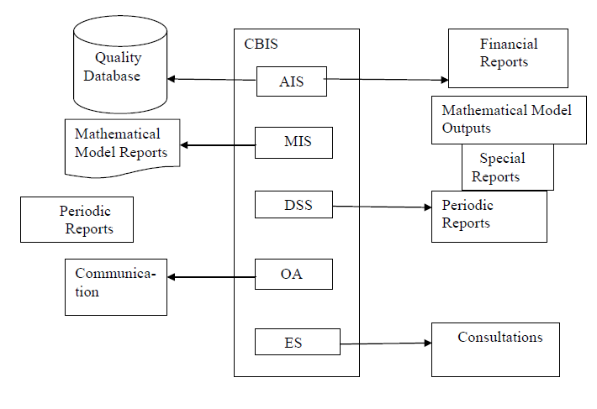

**UNIT – II:** Organization for MIS: Structure for Management; Information requirements at various levels of Management; Manual vs. computerized information system; Data Bank Concept; Types of

Computer-Based /applications

**Types of information systems**:

1.Transaction processing system(TPS): Txn can be internal, cross-department, external.

Steps in processing system

1. Data entry: Input devices, source document

2. Data validation: for accuracy and reliability, Error detection & correction

3. Processing & revalidation: modes: Online txn processing (eCom, ATM, rail reservation, etc) & batch processing (expenses report, salary, etc)

4. Storage

5. Output generation: either onscreen forms or Documents & reports like Invoices, pay checks, purchase invoices, sales receipts & job orders

6. Query support like chat, PoD

**Characteristics:**

✓ **Input:** Transaction related data.

✓ **Processing:** Use procedure & rules.

✓ **Output:** Summaries of transaction.

✓ **Users:** Lower-level managers.

✓ **Application:** Sales transaction applications, Credit & payment, Insurance claims.

2.Management information system(MIS): uses TPS outputs for decision making in planning, organizing, staffing, coordinating, reporting, budgeting, etc

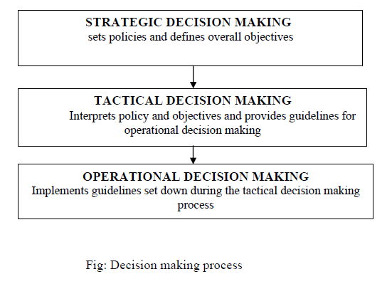

**Types of Decisions:**

1. Structured decisions: can be programmed.

2. Unstructured decisions**:** decision maker must provide judgment, evaluation and insights

**Characteristics:**

✓ **Input:** Output from TPS & other internal data.

✓ **Processing:** Measures & monitors operational performance.

✓ **Output:** Summary & exception reports.

✓ **Users:** Middle level managers.

✓ **Application:** Monthly production report.

**3. Intelligent support systems(ISS)**: consisting of

- decisions support systems (DSS): are interactive, well integrated systems that provide managers with data, tools and models to facilitate semi-structured decisions or tactical decisions. In outline, DSS require a database, the software to handle the database.

✓ There should be a large data base,

✓ Large amount of computation or data manipulation,

✓ Complex interrelationships,

✓ Analysis by stages,

✓ Judgment required and

✓ Communication

- executive information systems(EIS): user friendly interactive system. It has excellent menus graphic capabilities. A typical way that an EIS works is by exception reporting and drilling down to investigate the causes.

**Characteristics:**

✓ **Input:** Internal & external data & models.

✓ **Processing:** Interactive ad-hoc reporting.

✓ **Output:** Alternatives & Analysis reports.

✓ **Users:** Top managers.

✓ **Application:** Investment portfolios.

- AI and expert systems(ES): AI is a branch of computer science to design and develop machines that emulate human intelligence. ES is also known as knowledge based system. It is a software designed to capture the knowledge and problem solving skills of human expert. It has three main components: a knowledge base, an inference engine, and a user interface.

4.Office automation system(OAS): to enhance communication in the work place & increase the efficiency & productivity of knowledge workers or clerical workers. OAS includes:

❖ Word processing (templates, formats, styles, drafts, versions)

❖ Electronic mail

❖ Voice mail (trim, clips, compression, encryption)

❖ Audio conferencing

❖ Video conferencing

❖ Computer conferencing

❖ Tele conferencing

❖ Facsimile transmission: fax is the transfer of written or pictorial information by the use of special equipment that can read a document image at one end of a communication channel & make a copy at the other end.

❖ Desktop publishing (pamphlets, invitations, postures)

❖ Video task

❖ Imaging (char recognition, char extraction, optical reader)

❖ Multimedia system

**Characteristics:**

✓ **Input:** Data & information.

✓ **Processing:** Formatting, Summarizing & Displaying.

✓ **Output:** Document, Graphics, Multimedia.

✓ **Users:** Knowledge & Clerical workers.

✓ **Application:** Fax, Multimedia, Video conferencing.

**Computer block diagram/Hardware hierarchy/intro**

Magnetic ink character recognition (MICR): can identify character printed with a special ink that contains particles of magnetic material. This device particularly finds applications in banking industry.

• Optical mark recognition (OMR): also called mark sense reader is a technology where an OMR device senses the presence or absence of a mark, such as pencil mark. OMR is widely used in tests such as aptitude test.

• Bar-code readers are photoelectric scanners that read the bar codes or vertical zebra strips marks, printed on product containers. These devices are generally used in super markets, bookshops etc.

**Software:** Machine, Assembly, Interpreter based (COBOL, FORTAN & PL/I), HLL, OOP, System/Application S/W

**UNIT – III:** Data Base Management: Meaning of Data-Base; Electronic Data-Base; DBMS – Objectives –Technical Overview – Data Aggregates – Physical and Logical Structures; System Security

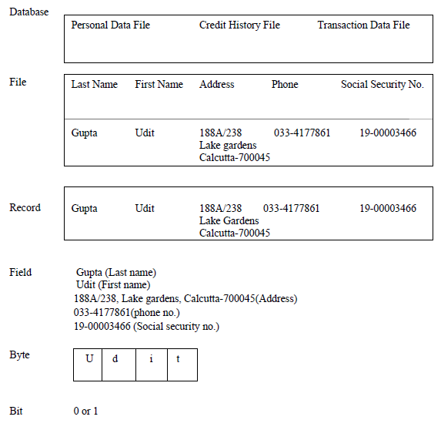

**The main disadvantages of the file based system** is

➢ Data redundancy

➢ Data integrity

➢ Data availability

➢ Management control

**Database and database management system (DBMS)**: collection of programs that enables us to store, modify, and extract information from a database.

**Components of a DBMS**

• Data Dictionary System(DDS): contains a database's metadata such as data ownership, data relationships to other objects, and other data. As it is crucial, only database administrators interact with the data dictionary.

• Data Definition Language(DDL): statements create, modify, and remove database objects such as tables, indexes, and users. Common DDL statements are CREATE, ALTER, and DROP.

• Data Manipulation Language(DML): to retrieve, insert and modify database information

**SQL:** First developed in the early 1970s at IBM by Raymond Boyce and Donald Chamberlin, SQL was commercially released by Relational Software Inc. (now known as Oracle Corporation) in 1979. The current standard SQL version is voluntary, vendor-compliant and monitored by the American National Standards Institute (ANSI). Most major vendors also have proprietary versions that are incorporated and built on ANSI SQL, e.g., SQL*Plus (Oracle), and Transact-SQL (T-SQL) (Microsoft).

**Database Models:** Hierarchical (Parent child tree structure), Networking Model for many-to-many relationships in data and Relational Model

**Relational Model:** uses table (collection of records and each record in a table contains the same fields.) to store/retrieve data.

**Properties of Relational Tables:**

• Values Are Atomic. • Each Row is Unique. • Column Values Are of the Same Kind. • The Sequence of Columns is Insignificant. • The Sequence of Rows is Insignificant •Each Column Has a Unique Name

Certain fields may be designated as keys.

ORDBMS:

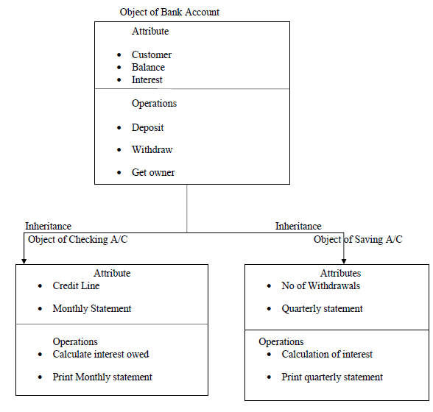

**ER Diagram:** entity-relationship (ER) diagram is a graphical representation of entities and their relationships to each other, like 1-1(regNo), 1-M (teacher-student, dept-staff), M-M (teacher-subjects, developers-projects) – sysbols

Distributed DBMS: Railways, corporates with branches across.

**UNIT – IV:** System Development Stages: Investigation, Analysis Design, Construction, Testing,

Implementation, Maintenance

**UNIT – V:** MIS in functional areas of Management: MIS for Marketing, Human Resource, Operations, Finance, General Management – Decision Making.

**MIS Classification:**

**1. Based on Functional Area**

MIS can be developed for specific departments within an organization:

* **Marketing Information System** – Supports market analysis, customer relationship management, sales forecasting.
* **Finance Information System** – Handles budgeting, financial planning, and investment analysis.
* **Human Resource Information System (HRIS)** – Manages employee records, payroll, performance, recruitment.
* **Production/Manufacturing Information System** – Manages production planning, inventory control, quality control.

**2. Based on Support Level**

MIS can be classified by the type of support it provides to management:

| **System Type** | **Description** | **Users** |
| --- | --- | --- |
| **Transaction Processing Systems (TPS)** | Automates routine, day-to-day business transactions (e.g., sales, payroll). | Operational-level employees |
| **Management Information Systems (MIS)** | Provides periodic reports based on routine data (e.g., sales summaries). | Middle management |
| **Decision Support Systems (DSS)** | Helps in decision-making by analyzing data and presenting simulation, forecasting tools. | Managers, analysts |
| **Executive Information Systems (EIS)** | Provides top executives with easy access to internal and external information. | Senior executives |
| **Office Automation Systems (OAS)** | Supports daily work activities like communication, document management. | Clerical staff, all employees |

**3. Based on Type of Decision**

MIS can be tailored to the type of decisions:

* **Structured Decision Systems** – For routine, well-defined decisions (e.g., reordering stock).
* **Semi-structured Decision Systems** – Combine judgment with data (e.g., budget allocation).
* **Unstructured Decision Systems** – For complex, non-routine decisions (e.g., entering a new market).

**4. Based on Nature of Processing**

* **Batch Processing Systems** – Process data in groups at scheduled times (e.g., payroll).
* **Real-Time Processing Systems** – Immediate data processing (e.g., airline reservation).

**5. Based on Technology Use**

* **Manual MIS** – Based on paper records and reports.
* **Computerized MIS** – Uses IT infrastructure, databases, and networks for data processing and reporting.